Low-saturation, Low-voltage 2 Channels
Bi-directional Motor Driver

Description  The FP5501 is a monolithic IC for low-saturation bi-directional low cost and high efficiency miniature two DC motor or stepper motor applications, such as driving shutter (DC actuator), auto-focus (stepper motor), iris (stepper motor) and accurate zoom (stepper motor) on cameras, vibration on mobile phone and other motor applications on portable devices. | Features  - Low Voltage Operation (V_{CC} Min=1.8V)  - Full- and Half-Stepping Capability  - Low Saturation Voltage (Upper + Low Transistor Residual Voltage; 0.46V typ. at 400mA)  - Low Input Current  - Low Operating Current, Sleep Mode with Zero Current Drain  - Dead-Zone Protection  - High Output Sinking and Driving Capability  - Small, Thin, Highly Reliable Package (TDFN-10)  - Available COB Package  - Thermal Shutdown Protection  Applications  - Stepper Motor  - DSC  - Camera Module  - Motor Application on Portable Device

Pin Assignments | Ordering Information  FP5501□□□
  WD Package (TDFN-10)(3mm×3mm)
  Figure 1. Pin Assignment of FP5501 (Top View)
  Package Type
  WD: TDFN-10 (3mm×3mm)
  CH: CHIP
  TR: Tape/Reel
  Blank: Tube
  P: Green

Block Diagram & Application Circuit
1. Shutter & Iris application
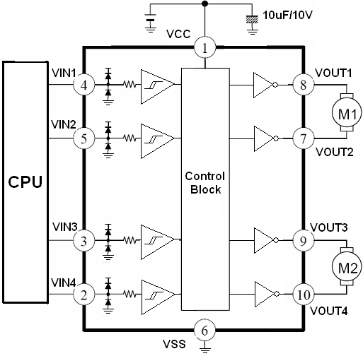
Figure 1a. Dual DC Motor Application
2. Stepping motor for 1-2 phase excitation
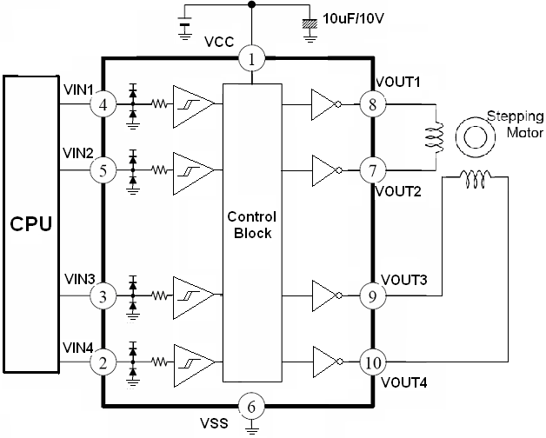
Figure 1b. Stepper Motor Application

3. Typical single dc motor control (paralleled outputs)
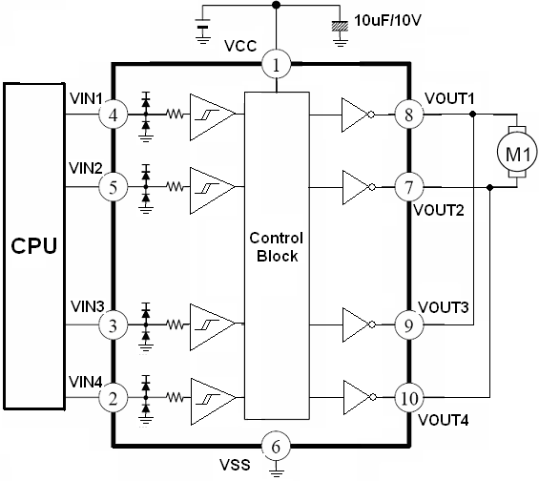
Figure 1c. Single (paralleled) DC Motor Application

Functional Pin Description
Pin No. | Pin Name | Pin Function
1 | VCC | Power supply pin.
2 | VIN4 | Input pin.
3 | VIN3 | Input pin.
4 | VIN1 | Input pin.
5 | VIN2 | Input pin.
6 | VSS | Ground pin.
7 | VOUT2 | Output sinking or driving current pin.
8 | VOUT 1 | Output driving or sinking current pin.
9 | VOUT 3 | Output sinking or driving current pin.
10 | VOUT 4 | Output driving or sinking current pin.
Block Diagram
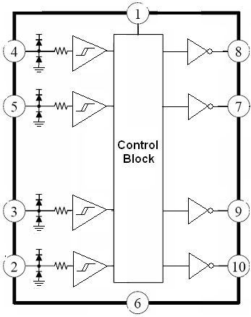
Figure 2. Block Diagram of FP5501

Absolute Maximum Ratings
● VCC to VSS ----------------------------------------------------------------------------------------------- | -0.3V to +5.5V
● VIN and VOUT to VSS ---------------------------------------------------------------------------------- | -0.3V to +6V
● Output Current per Channel *1 ----------------------------------------------------------------------- | 0mA to 400mA
● Continuous Power Dissipation ------------------------------------------------------------------------ | 486mW
● Junction Temperature ----------------------------------------------------------------------------------- | +150°C
● Storage Temperature Range -------------------------------------------------------------------------- | -65°C to +150°C
● Lead Temperature (Soldering, 10sec.) ------------------------------------------------------------- | 260°C
● ESD (Human Body Model) *2 ------------------------------------------------------------------------- | 4000V
*1: Output current rating may be limited by ambient temperature and heat sinking. Under any set of conditions, do not exceed the specified.
*2: ESD caution: ESD (electrostatic discharge) sensitive device. Electrostatic charges as high as 4000V readily accumulate on the human body and test equipment and can discharge without detection. Although this product features proprietary ESD protection circuitry, permanent damage may occur on devices subjected to high energy electrostatic discharges. Therefore, proper ESD precautions are recommended to avoid performance degradation or loss of functionality.
Recommended Operating Conditions
● Supply Voltage VCC to VSS -------------------------------------------------------------------------- | 1.8V to 5.5V
● Maximum Output Drop Voltage (400mA Output Current) -------------------------------------- | 0.46V
● Operation Temperature Range ----------------------------------------------------------------------- | -40°C to +125°C

Electrical Characteristics
(Unless otherwise noted, T_{A}=25°C & V_{CC}=3V)
Parameter | Symbol | Conditions | Min. | Typ. | Max. | Unit
Supply Voltage | V_{CC} |  | 1.8 | 3.0 | 5.5 | V
Supply Current  ( I_{CC} + I_{SS}) | I_{CC0} | V_{VIN1, VIN2, VIN3, VIN4}=0V | - | 0.1 | 10 | μA
Supply Current  ( I_{CC} + I_{SS}) | I_{CC1} | V_{VIN1, VIN2, VIN3, VIN4}≠0V | - | 0.15 | 0.4 | mA
VIN 1 / VIN 2 / VIN3 / VIN4 Input Terminal ( T_{J}=25°C)
Input Voltage “H” | V_{INH} |  | 1.5 | - |  | V
Input Voltage “L” | V_{INL} |  |  | - | 0.4 | V
Input Voltage Hysteresis | V_{Hsy} |  | - | 0.42 | - | V
Input Current “H” | I_{INH} | V_{IN}=V_{CC} | - | - | 5 | μA
Input Current “L” | I_{INL} | V_{IN}=0V | - | - | 5 | μA
VOUT1 / VOUT 2 / VOUT 3 / VOUT 4 Output Terminal (T_{J}=25°C)
Output Voltage  (Upper + Lower) | V_{SAT1} | I_{OUT}=200mA | - | 0.22 | 0.4 | V
Output Voltage  (Upper + Lower) | V_{SAT2} | I_{OUT}=400mA | - | 0.46 | 0.7 | V
Thermal Protection Circuit
Protection Temperature | T_{TSD} | V_{VIN1, VIN2, VIN3, VIN4}=H | - | 150 | - | °C
Temperature Hysteresis | T_{Hsy} | V_{VIN1, VIN2, VIN3, VIN4}=H | - | 25 | - | °C
Truth Table
VIN1 or 3 | VIN2 or 4 | VOUT1 or 3 | VOUT2 or 4 | Mode
Low | Low | OFF | OFF | Standby
High | Low | High | Low | Forward
Low | High | Low | High | Reverse
High | High | --- | --- | Keep the Previous Mode (Forward / Reverse)

Truth Table Test Waves
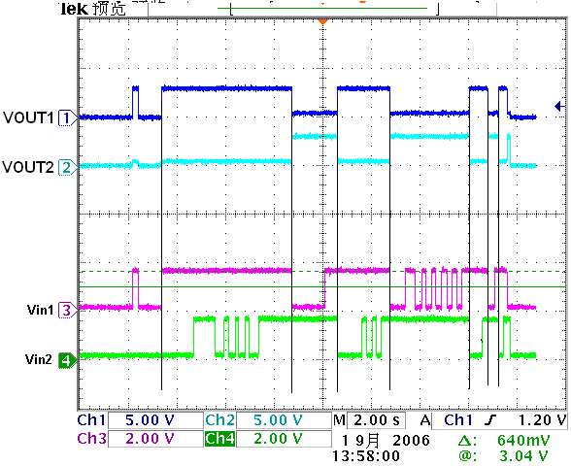
Figure 3. Truth Table Test Waves
Characteristic Performance Curve
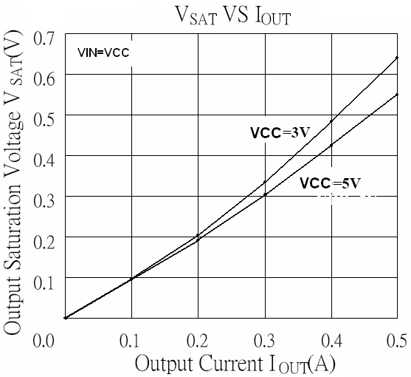 | 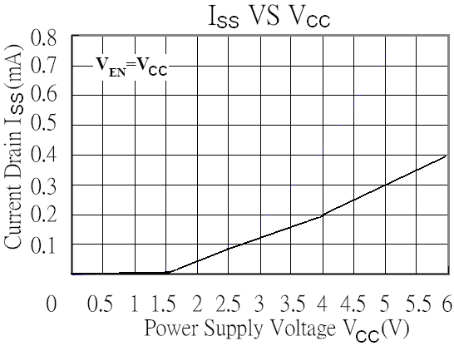
Figure 4a. V_{SAT} vs. I_{OUT} | Figure 4b. I_{SS} vs. V_{CC}

Motor Operation Truth Table
INX *1 |  |  |  | VOUT1*2 |  | VOUT2 |  | VOUT3 |  | VOUT4 |  | Function
Stepper Motor
VIN1 | VIN2 | VIN3 | VIN4 | VOUT1*2 |  | VOUT2 |  | VOUT3 |  | VOUT4 |  | Full-Stepping |  | Half-Stepping
0 | 0 | 0 | 0 | OFF |  | OFF |  | OFF |  | OFF |  | Sleep Mode |  | Sleep Mode
1 | 0 | 1 | 0 | H |  | L |  | H |  | L |  | Step1 *3 |  | Step1
0 | 0 | 1 | 0 | OFF |  | OFF |  | H |  | L |  | Step1_1 *4 |  | Step2
0 | 1 | 1 | 0 | L |  | H |  | H |  | L |  | Step2 |  | Step3
0 | 1 | 0 | 0 | L |  | H |  | OFF |  | OFF |  | Step2_1 |  | Step4
0 | 1 | 0 | 1 | L |  | H |  | L |  | H |  | Step3 |  | Step5
0 | 0 | 0 | 1 | OFF |  | OFF |  | L |  | H |  | Step3_1 |  | Step6
1 | 0 | 0 | 1 | H |  | L |  | L |  | H |  | Step4 |  | Step7
1 | 0 | 0 | 0 | H |  | L |  | OFF |  | OFF |  | Step4_1 |  | Step8
DC Motor (Dual)
VIN1 or VIN3 |  | VIN2 or VIN4 |  | VOUT1*2 |  | VOUT2 |  | VOUT3 |  | VOUT4 |  | Function
0 |  | 0 |  | OFF |  | OFF |  | OFF |  | OFF |  | Sleep Mode
1 |  | 0 |  | H |  | L |  | H |  | L |  | Forward
0 |  | 1 |  | L |  | H |  | L |  | H |  | Reverse
1 |  | 1 |  | -- |  | -- |  | -- |  | -- |  | Keep the previous mode  (Forward/Reverse)
DC Motor (Single, Paralleled)
VIN1 or VIN3 |  | VIN2 or VIN4 |  |  | VOUT1*2 |  | VOUT2 |  | VOUT3 |  | VOUT4 |  | Function
0 |  | 0 |  |  | OFF |  | OFF |  | OFF |  | OFF |  | Sleep Mode
1 |  | 0 |  |  | H |  | L |  | H |  | L |  | Forward
0 |  | 1 |  |  | L |  | H |  | L |  | H |  | Reverse
1 |  | 1 |  |  | -- |  | -- |  | -- |  | -- |  | Keep the previous mode  (Forward/Reverse)
*1: 0=logic low, Vinx<V_{IL} (max.); 1=logic high, Vinx>V_{IH} (min.).
*2: H=voltage high, source driver on; L=voltage low, sink driver on.
*3: Two phase on stepper motor drive
*4: One phase on stepper motor drive

Function Description
Device Operation
The FP5501 is a dual full-bridge low voltage motor driver capable of operating one stepper motor or up to two dc motors. MOSFET output stages substantially reduce the voltage drop and the power dissipation of the outputs of the FP5501 compared to typical drivers with bipolar transistors. Internal circuit protection includes thermal shutdown with hysteresis and crossover current protection. The FP5501 is designed for portable applications with a power-off (sleep mode) current of 100nA typical, and an operating voltage of 1.8V to 5.5V.
The FP5501 logic inputs are 3 to 5V logic compatible.
In conditions where the logic supply voltage drops below 1.8V, both the sink and the source voltage drop will increase beyond the specified values. In extreme cases, no power will be delivered to the motors. However, the device will not be damaged.
In stepping operation, the device can drive in either full- or half-step mode. The stepping mode is set by the signal pattern on the Inx terminals, as shown in the stepping timing diagrams.
Sleep Mode
Pulling all inputs to 0.4V or less, sends the FP5501 to sleep mode, during which it draws 100nA typical.
Thermal Shutdown
The FP5501 will disable the outputs if the junction temperature reaches 150ºC. When thermal shutdown is entered, after the junction temperature drops 15ºC, the outputs will be re-enabled.
Application Notes

Figure 5a. Typical stepper motor control application

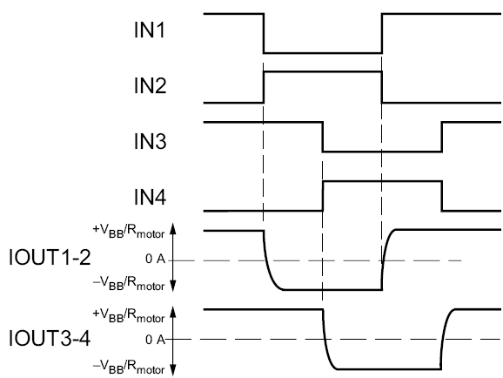

Figure 5b. Full step mode timing chart (two phase on)

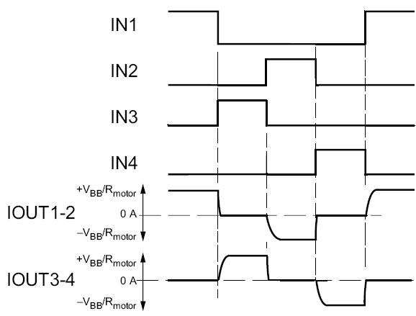

Figure 5c. Full step mode timing chart (one phase on)

Application Notes (Continued)
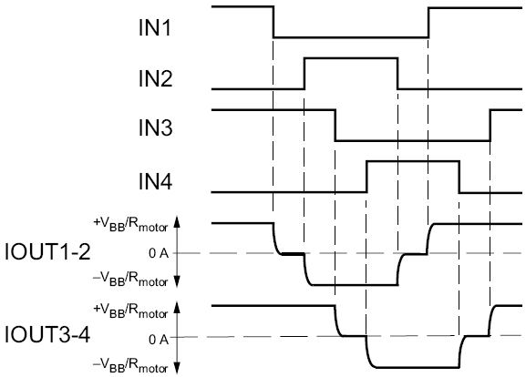

Figure 5d. Half step mode timing chart

Figure 6. Typical dual dc motor control application.
Either IN1 or IN2 and be used to drive OUT1 and OUT2. Either IN3 or IN4 and be used to drive OUT3 and OUT4.

Application Notes (Continued)
Figure 7. Typical single dc motor control application (paralleled outputs).

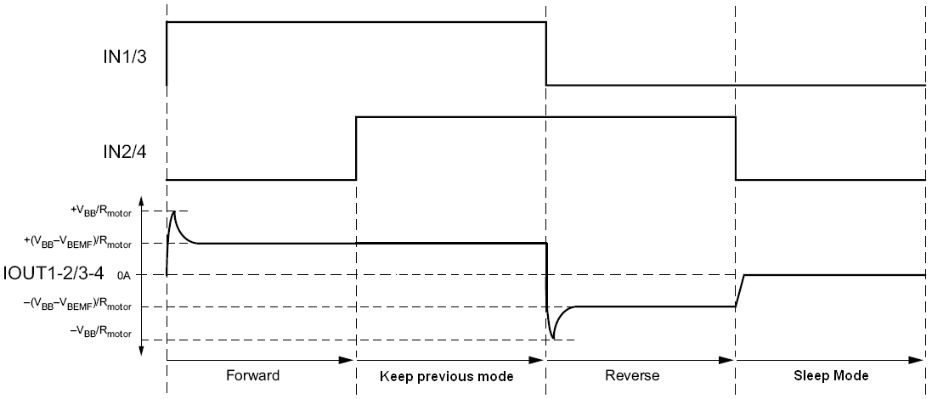
Figure 8. Typical dual dc motor control application (timing chart)
The power dissipated by the IC varies widely with the supply voltage, the output current, and loading. It is important to ensure the application does not exceed the allowable power dissipation of the IC package. The recommended motor driver power dissipation versus temperature is depicted as follows:
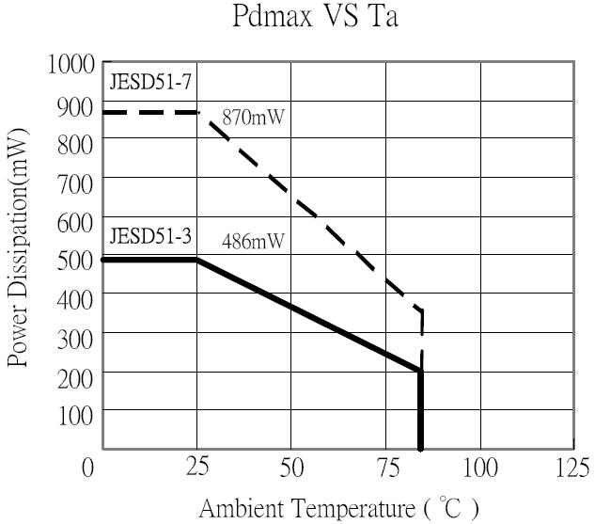

Outline Information
TDFN-10 3mm x 3mm (pitch 0.5 mm) Package (Unit: mm)
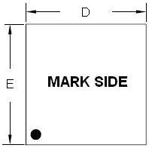  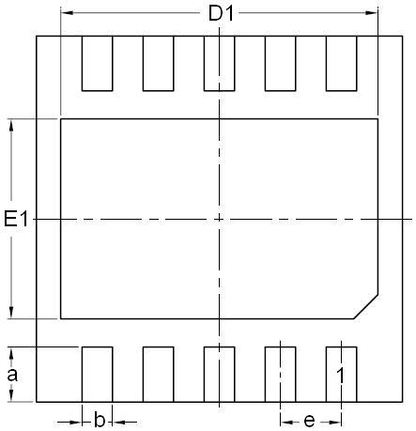  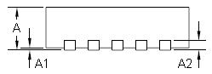
  SYMBOLS UNIT | DIMENSION IN MILLIMETER
  SYMBOLS UNIT | MIN | MAX
  A | 0.70 | 0.80
  A1 | 0.00 | 0.05
  A2 | 0.18 | 0.25
  D | 2.95 | 3.05
  E | 2.95 | 3.05
  a | 0.30 | 0.50
  b | 0.18 | 0.30
  e | 0.45 | 0.55
  D1 | 2.20 | 2.70
  E1 | 1.40 | 1.75
Carrier Dimensions
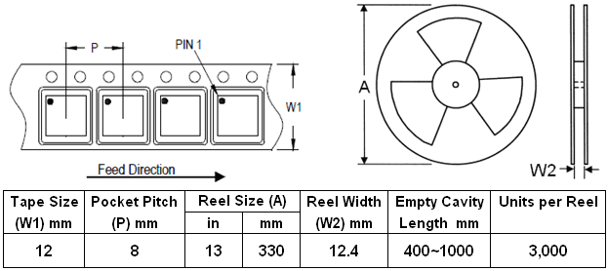

Life Support Policy
Fitipower’s products are not authorized for use as critical components in life support devices or other medical systems.

