18V, 2.5A Synchronous Step-Down
DC/DC Converter

Description  The FR9204FH is a synchronous step-down DC/DC converter with fast constant on time (FCOT) mode control. The device provides 4.5V to 18V input voltage range and 2.5A continuous load current capability. It is constant on time pulse width modulation (PWM) controller that supports FCOT mode control. Operation frequency depends on Input and output voltage condition.  The FR9204FH fault protection includes cycle-by-cycle current limit, short circuit protection, UVLO and thermal shutdown. The soft-start function prevents inrush current at turn-on. The FR9204FH use fast constant on time control that provides fast transient response, the noise immunity and all kinds of very low ESR output capacitor for ensuring performance stabilization.  The FR9204FH is offered in TSOT-23-6 and SOT-563-6 packages, which provides good thermal conductance. | Features  - Low R_{DS(ON)} Integrated Power MOSFET (80mΩ/40mΩ)  - Wide Input Voltage Range: 4.5V to 18V  - Output Voltage Range: 0.768V to 8V(FR9204FHS9)  - Output Voltage Range: 0.8V to 8V(FR9204FHSD)  - 2.5A Output Current  - FCOT Mode Enables Fast Transient Response  - Pseudo 1.2MHz Frequency  - Input Under Voltage Lockout  - Internal 1.5ms Soft-Start  - Cycle-by-Cycle Current Limit  - Hiccup Short Circuit Protection  - Over Temperature Protection with Auto Recovery  - TSOT-23-6 and SOT-563-6 Packages  Applications  - STB (Set-Top-Box)  - LCD Display, TV  - Distributed Power System  - Networking, XDSL Modem
Pin Assignments | Ordering Information  FR9204FH□  Marking
  S9 Package: TSOT-23-6
  SD Package: SOT-563-6
  Figure 1. Pin Assignments of FR9204FH
  Package Type
  S9: TSOT-23-6
  SD: SOT-563-6
  Part Number | Product Code
  FR9204FHS9 | CH4
  FR9204FHSD | At

Typical Application Circuit
Figure 2. FR9204FHS9 Application Circuit

V_{IN}=12V, the recommended BOM list is as below.
V_{OUT} | C1 | R1 | R2 | C4 | L1 | C2
1.05V | 22μF MLCC | 3.74kΩ | 10kΩ | 68pF~220pF | 0.68μH | 22μF MLCC x2
1.2V | 22μF MLCC | 5.76kΩ | 10kΩ | 68pF~220pF | 0.68μH | 22μF MLCC x2
1.8V | 22μF MLCC | 13.7kΩ | 10kΩ | 68pF~220pF | 1μH | 22μF MLCC x2
2.5V | 22μF MLCC | 22.6kΩ | 10kΩ | 68pF~220pF | 1μH | 22μF MLCC x2
3.3V | 22μF MLCC | 33.2kΩ | 10kΩ | 68pF~220pF | 1.5μH | 22μF MLCC x2
5V | 22μF MLCC | 54.9kΩ | 10kΩ | 68pF~220pF | 1.5μH | 22μF MLCC x2
Table 1. FR9204FHS9 Recommended Component Values

Typical Application Circuit (Continued)
Figure 3. FR9204FHSD Application Circuit

V_{IN}=12V, the recommended BOM list is as below.
V_{OUT} | C1 | R1 | R2 | C4 | L1 | C2
1.05V | 22μF MLCC | 4.87kΩ | 16.2kΩ | 68pF~220pF | 0.68μH | 22μF MLCC x2
1.2V | 22μF MLCC | 4.87kΩ | 10kΩ | 68pF~220pF | 0.68μH | 22μF MLCC x2
1.8V | 22μF MLCC | 4.87kΩ | 3.92kΩ | 68pF~220pF | 1μH | 22μF MLCC x2
2.5V | 22μF MLCC | 4.87kΩ | 2.32kΩ | 68pF~220pF | 1μH | 22μF MLCC x2
3.3V | 22μF MLCC | 30.1kΩ | 9.76kΩ | 68pF~220pF | 1.5μH | 22μF MLCC x2
5V | 22μF MLCC | 30.1kΩ | 5.76kΩ | 68pF~220pF | 1.5μH | 22μF MLCC x2
Table 2. FR9204FHSD Recommended Component Values

Functional Pin Description
Pin Name | Pin No.  TSOT-23-6 | Pin No.  SOT-563-6 | Pin Function
GND | 1 | 3 | Ground pin.
LX | 2 | 2 | Power switching node. Connect an external inductor to this switching node.
VIN | 3 | 1 | Power supply input pin. Placed input capacitors as close as possible from VIN to GND to avoid noise influence.
FB | 4 | 6 | Voltage feedback input pin. Connect FB and VOUT with a resistive voltage divider. This IC senses feedback voltage via FB and regulates it at 0.768V (FR9204FHS9) or 0.8V (FR9204FHSD).
$$\overline{\text{SHDN}}$$ | 5 | 5 | Enable input pin. Pull high to turn on IC, and pull low to turn off IC. Connect VIN with a 100kΩ resistor for self-startup.
BST | 6 | 4 | High side gate drive boost pin. A capacitance between 100nF~1μF must be connected from this pin to LX. It can boost the gate drive to fully turn on the internal high side NMOS.
Block Diagram

Figure 4. Block Diagram of FR9204FH

Absolute Maximum Ratings ^{(Note 1)}
● Supply Voltage V_{IN} ------------------------------------------------------------------------------------------- |  | -0.3V to +20V
● Enable Voltage ${\text{V}}_{\overline{\text{SHDN}}}$ ------------------------------------------------------------------------------------- |  | -0.3V to +20V
● LX Voltage V_{LX} ------------------------------------------------------------------------------------------------ |  | -0.3V to (V_{IN} +0.3V)
● Dynamic LX Voltage in 15ns Duration------------------------------------------------------------------- |  | -5V to V_{IN} +5V
● BST Pin Voltage V_{BST} --------------------------------------------------------------------------------------- |  | -0.3V to (V_{LX} +6.5V)
● All Other Pins Voltage -------------------------------------------------------------------------------------- |  | -0.3V to +6V
● Maximum Junction Temperature (T_{J}) ------------------------------------------------------------------- |  | +150°C
● Storage Temperature (T_{S}) --------------------------------------------------------------------------------- |  | -65°C to +150°C
● Lead Temperature (Soldering, 10sec.) ----------------------------------------------------------------- |  | +260°C
● Package Thermal Resistance, (θ_{JA}) ^{(Note 2)}
 | TSOT-23-6 ----------------------------------------------------------------------------------------- | 85°C/W
 | SOT-563-6 ----------------------------------------------------------------------------------------- | 130°C/W
● Package Thermal Resistance, (θ_{JC})
 | TSOT-23-6 ----------------------------------------------------------------------------------------- | 20°C/W
 | SOT-563-6 ----------------------------------------------------------------------------------------- | 60°C/W

Note 1: Stresses beyond this listed under “Absolute Maximum Ratings" may cause permanent damage to the device.
Note 2: θ_{JA} is measured at 25°C ambient with the component mounted on a high effective thermal conductivity 4-layer board of JEDEC-51-7. The thermal resistance greatly varies with layout, copper thickness, number of layers and PCB size.

Recommended Operating Conditions
● Supply Voltage V_{IN} ------------------------------------------------------------------------------------------ | +4.5V to +18V
● Operating Ambient Temperature Range -------------------------------------------------------------- | -40°C to +85°C
● Operating Junction Temperature Range -------------------------------------------------------------- | -40°C to +125°C

Electrical Characteristics
(V_{IN}=12V, T_{A}=25°C, unless otherwise specified.)
Parameter | Symbol | Conditions | Min | Typ | Max | Unit
V_{IN} Quiescent Current | I_{DDQ} | ${\text{V}}_{\overline{\text{SHDN}}}$=2V, V_{FB}=1V |  | 0.3 |  | mA
V_{IN} Shutdown Supply Current | I_{SD} | ${\text{V}}_{\overline{\text{SHDN}}}$=0V |  | 0.1 | 1 | μA
Feedback Threshold Voltage (FR9204FHS9) | V_{FB} | 4.5V≦V_{IN}≦18V | 0.757 | 0.768 | 0.779 | V
Feedback Threshold Voltage (FR9204FHSD) | V_{FB} | 4.5V≦V_{IN}≦18V | 0.788 | 0.8 | 0.812 | V
Feedback Input Current | I_{FB} | V_{FB}=1V |  | 0.01 | 0.1 | μA
High-Side MOSFET R_{DS(ON)} | R_{DS(ON)} |  |  | 80 |  | mΩ
Low-Side MOSFET R_{DS(ON)} | R_{DS(ON)} |  |  | 40 |  | mΩ
Valley Current Limit ^{(Note 3)} | I_{LIMIT} |  | 3.3 | 4 | 5.3 | A
On Time ^{(Note 3)} | T_{ON} | V_{IN}=12V, V_{OUT}=1.05V |  | 100 |  | ns
Minimum Off Time | T_{OFF(MIN)} | V_{FB}=0.4V |  | 150 |  | ns
Input Supply Voltage UVLO Threshold | V_{UVLO(Vth)} | V_{IN} Rising | 3.7 | 4 | 4.3 | V
UVLO Threshold Hysteresis | V_{UVLO(HYS)} |  |  | 0.25 |  | V
Internal Soft-Start Period ^{(Note 3)} | T_{SS} |  |  | 1.5 |  | ms
$\overline{\text{SHDN}}$Input Low Voltage | $${\text{V}}_{\overline{\text{SHDN}}\text{(}\text{L}\text{)}}$$ |  |  |  | 0.5 | V
$\overline{\text{SHDN}}$ Input High Voltage | $${\text{V}}_{\overline{\text{SHDN}}\text{(}\text{H}\text{)}}$$ |  | 1.5 |  |  | V
$\overline{\text{SHDN}}$ Input Current | $${\text{I}}_{\overline{\text{SHDN}}}$$ | ${\text{V}}_{\overline{\text{SHDN}}}$=2V |  | 2 |  | μA
Thermal Shutdown Threshold ^{(Note 3)} | T_{SD} |  |  | 160 |  | °C
Thermal Shutdown Hysteresis ^{(Note 3)} | T_{HYS} |  |  | 30 |  | °C
Note 3: Not production tested.

Typical Performance Curves
V_{OUT}=1.05V | V_{OUT}=3.3V
Figure 5. Efficiency vs. Load Current | Figure 6. Efficiency vs. Load Current
V_{OUT}=5.0V | V_{IN}=12V, V_{OUT}=3.3V, I_{OUT}=0A~2.5A
Figure 7. Efficiency vs. Load Current | Figure 8. Switch Frequency vs. Load Current
V$\overline{\text{SHDN}}$=2V, V_{FB}=1V | V_{IN}=12V
Figure 9. Quiescent Current vs. Ambient Temperature | Figure 10. Feedback Voltage vs. Ambient Temperature

Typical Performance Curves (Continued)
V_{IN}=12V, V_{OUT}=3.3V, C1=22μF, C2=22μFx2, C4=82pF, L1=4.7μH, TA=+25°C, unless otherwise noted.
I_{OUT}=0A  V_{LX} 5V/div.  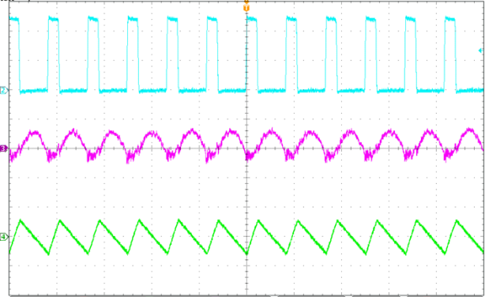  I_{L} 1A/div.  V_{OUT} 10mV/div.  1μs/div. | I_{OUT}=2.5A  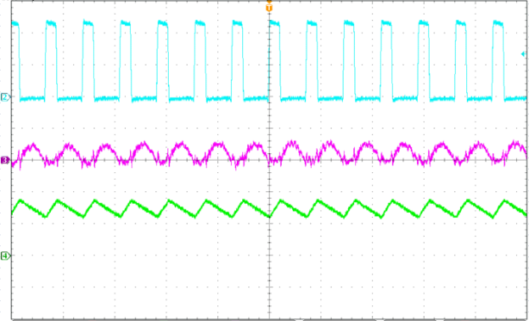  I_{L} 2A/div.  V_{OUT} 10mV/div.  V_{LX} 5V/div.  1μs/div.
Figure 11. Steady State Waveform | Figure 12. Steady State Waveform
I_{OUT}=0A  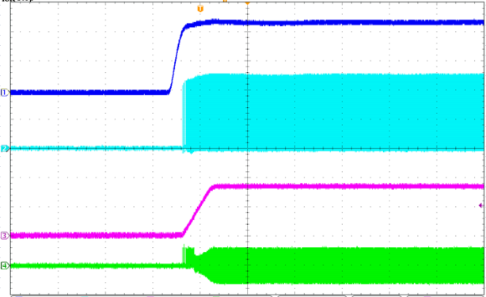  I_{L} 1A/div.  V_{OUT} 2V/div.  V_{IN} 5V/div.  V_{LX} 5V/div.  2ms/div. | I_{OUT}=2.5A  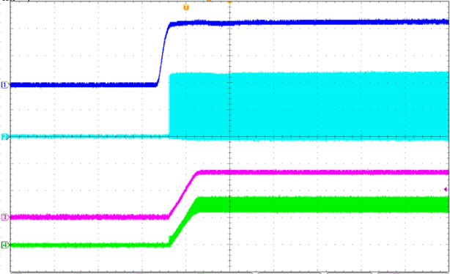  I_{L} 2A/div.  V_{OUT} 2V/div.  V_{LX} 5V/div.  V_{IN} 5V/div.  2ms/div.
Figure 13. Power On Through VIN Waveform | Figure 14. Power On Through VIN Waveform
I_{OUT}=0A  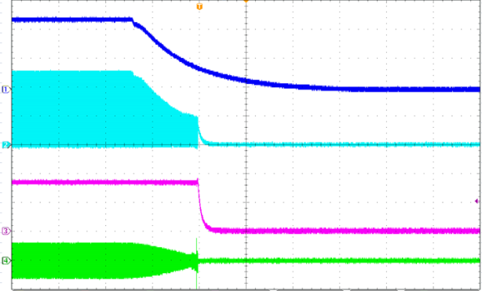  V_{IN} 5V/div.  V_{LX} 5V/div.  V_{OUT} 2V/div.  I_{L} 1A/div.  40ms/div. | I_{OUT}=2.5A  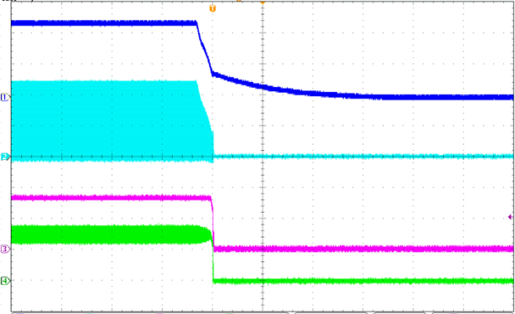  V_{IN} 5V/div.  V_{LX} 5V/div.  V_{OUT} 2V/div.  I_{L} 2A/div.  40ms/div.
Figure 15. Power Off Through VIN Waveform | Figure 16. Power Off Through VIN Waveform

Typical Performance Curves (Continued)
V_{IN}=12V, V_{OUT}=3.3V, C1=22μFx1, C2=22μFx2, C4=82pFx1, L1=4.7μH, TA=+25°C, unless otherwise noted.
I_{OUT}=0A  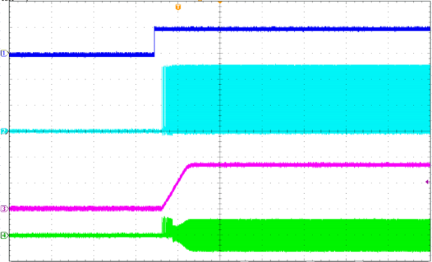  I_{L} 1A/div.  V_{OUT} 2V/div.  V_{LX} 5V/div.  ${\text{V}}_{\overline{\text{SHDN}}}$ 5V/div.  2ms/div. | I_{OUT}=2.5A  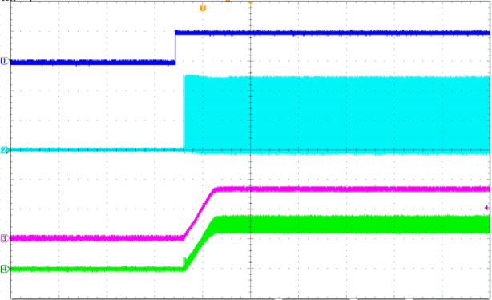  I_{L} 2A/div.  V_{OUT} 2V/div.  V_{LX} 5V/div.  ${\text{V}}_{\overline{\text{SHDN}}}$ 5V/div.  2ms/div.
Figure 17. Power On Through $\overline{\text{SHDN}}$ Waveform | Figure 18. Power On Through $\overline{\text{SHDN}}$ Waveform
I_{OUT}=0A  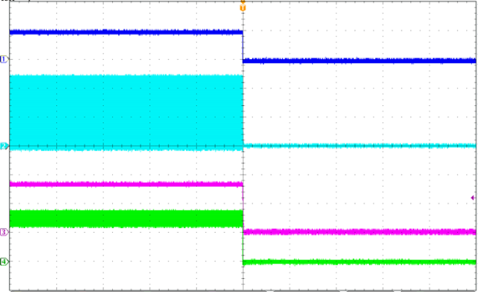  I_{L} 1A/div.  V_{OUT} 2V/div.  V_{LX} 5V/div.  ${\text{V}}_{\overline{\text{SHDN}}}$ 5V/div.  40ms/div. | I_{OUT}=2.5A  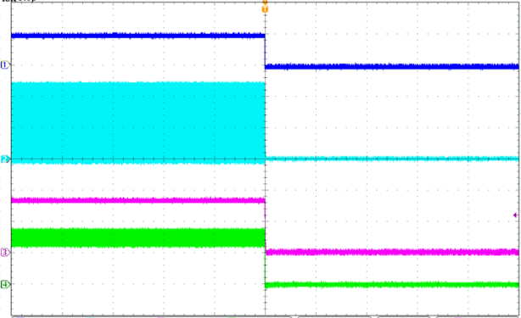  I_{L} 2A/div.  V_{OUT} 2V/div.  V_{LX} 5V/div.  ${\text{V}}_{\overline{\text{SHDN}}}$ 5V/div.  40ms/div.
Figure 19. Power Off Through $\overline{\text{SHDN}}$ Waveform | Figure 20. Power Off Through $\overline{\text{SHDN}}$ Waveform
I_{OUT}=1.5A to 2.5A
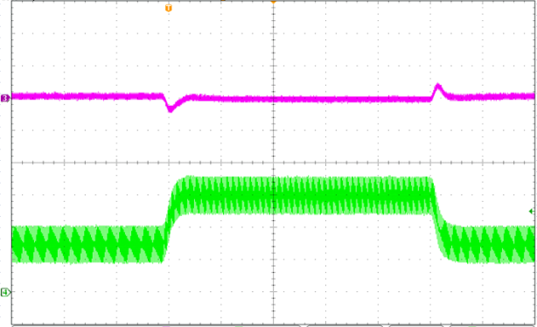
V_{OUT} 100mV/div.
I_{L} 1A/div.
40μs/div.
Figure 21. Load Transient Waveform

Function Description
The FR9204FH is a synchronous step-down DC/DC converter with fast constant on time (FCOT) mode control. It has integrated high-side (80mΩ, typ) and low-side (40mΩ, typ) power switches, and provides 2.5A continuous load current. It regulates input voltage from 4.5V to 18V, and down to an output voltage as low as 0.768V (FR9204FHS9) or 0.8V (FR9204FHSD). Using FCOT control scheme provides fast transient response, which can minimize the component size without additional external compensation network.  Enable  The FR9204FH $\overline{\text{SHDN}}$ pin provides digital control to turn on/turn off the regulator. When the voltage of $\overline{\text{SHDN}}$ exceeds the threshold voltage, the regulator starts the soft start function. If the $\overline{\text{SHDN}}$ pin voltage is below than the shutdown threshold voltage, the regulator will turn into the shutdown mode and the shutdown current will be smaller than 1μA. For auto start-up operation, connect $\overline{\text{SHDN}}$ to VIN through a 100kΩ resistor.  Soft Start  The FR9204FH employs internal soft start function to reduce input inrush current during start up. The typical value of internal soft start time is 1.5ms.  Input Under Voltage Lockout  When the FR9204FH is power on, the internal circuits are held inactive until V_{IN} voltage exceeds the input UVLO threshold voltage. And the regulator will be disabled when V_{IN} is below the input UVLO threshold voltage. The hysteretic of the UVLO comparator is 250mV (typ). | Over Current Protection  The FR9204FH over current protection function is implemented using cycle-by-cycle current limit architecture. The inductor current is monitored by Low-side MOSFET. When the load current increases, the inductor current also increases. When the valley inductor current reaches the current limit threshold, the output voltage starts to drop. When the over current condition is removed, the output voltage returns to the regulated value.  Short Circuit Protection  The FR9204FH provides short circuit protection function to prevent the device damage from short condition. When the short condition occurs and the feedback voltage drops lower than 0.33V, the oscillator frequency will be reduced naturally and hiccup mode will be triggered to prevent the inductor current increasing beyond the current limit. Once the short condition is removed, the frequency will return to normal.  Over Temperature Protection  The FR9204FH incorporates an over temperature protection circuit to protect itself from overheating. When the junction temperature exceeds the thermal shutdown threshold temperature, the regulator will be shutdown. And the hysteretic of the over temperature protection is 30°C (typ).

Application Information
Output Voltage Setting  The output voltage V_{OUT} is set using a resistive divider from the output to FB. The FB pin regulated voltage is 0.768V or 0.8V. Thus the output voltage equation is:  ${\text{V}}_{\text{OUT}}\text{=0.768V×}\left(\text{1+}\frac{\text{R1}}{\text{R2}}\right)$...(FR9204FHS9)  ${\text{V}}_{\text{OUT}}\text{=0.}\text{8}\text{V×}\left(\text{1+}\frac{\text{R1}}{\text{R2}}\right)$…..(FR9204FHSD)  Place resistors R1 and R2 close to FB pin to prevent stray pickup.  Input Capacitor Selection  The use of the input capacitor is filtering the input voltage ripple and the MOSFETS switching spike voltage. Because the input current to the step-down converter is discontinuous, the input capacitor is required to supply the current to the converter to keep the DC input voltage. The capacitor voltage rating should be 1.25 to 1.5 times greater than the maximum input voltage. The input capacitor ripple current RMS value is calculated as:  $${\text{I}}_{\text{CIN(RMS)}}\text{=}{\text{I}}_{\text{OUT}}\text{×}\sqrt{\text{D×}\left(\text{1-D}\right)}$$  $$\text{D=}\frac{{\text{V}}_{\text{OUT}}}{{\text{V}}_{\text{IN}}}$$  Where D is the duty cycle of the power MOSFET.  This function reaches the maximum value at D=0.5 and the equivalent RMS current is equal to I_{OUT}/2. The following diagram is the graphical representation of above equation.  2A  1A  2.5A  A low ESR capacitor is required to keep the noise minimum. Ceramic capacitors are better, but tantalum or low ESR electrolytic capacitors may also suffice. When using tantalum or electrolytic capacitors, a 0.1μF ceramic capacitor should be placed as close to the IC as possible. | Output Capacitor Selection  The output capacitor is used to keep the DC output voltage and supply the load transient current. When operating in constant current mode, the output ripple is determined by four components:  $${\text{V}}_{\text{RIPPLE}}\left(\text{t}\right)\text{=}{\text{V}}_{\text{RIPPLE}\left(\text{C}\right)}\left(\text{t}\right)\text{+}{\text{V}}_{\text{RIPPLE}\left(\text{ESR}\right)}\left(\text{t}\right)$$  $$\text{+}{\text{V}}_{\text{RIPPLE(ESL)}}\left(\text{t}\right)\text{+}{\text{V}}_{\text{NOISE}}\left(\text{t}\right)$$  The following figures show the form of the ripple contributions.  V_{RIPPLE(ESR)}(t)  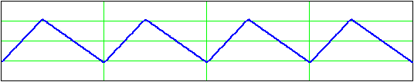  (t)  +  V_{RIPPLE(ESL)} (t)  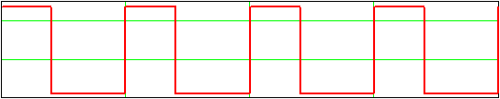  (t)  +  V_{RIPPLE(C)} (t)  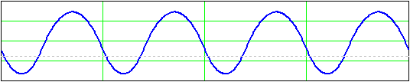  (t)  +  V_{NOISE} (t)  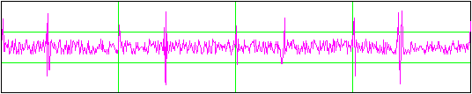  =  V_{RIPPLE}(t)  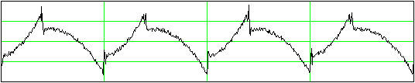  (t)

Application Information (Continued)
$${\text{V}}_{\text{RIPPLE(ESR)}}\text{=}\frac{{\text{V}}_{\text{OUT}}}{{\text{F}}_{\text{OSC}}\text{×}\text{L}}\text{×}\left(\text{1}\text{-}\frac{{\text{V}}_{\text{OUT}}}{{\text{V}}_{\text{IN}}}\right)\text{×}\text{ESR}$$  $${\text{V}}_{\text{RIPPLE(ESL)}}\text{=}\frac{\text{ESL}}{\text{L}}\text{×}{\text{V}}_{\text{IN}}$$  $${\text{V}}_{\text{RIPPLE(C)}}\text{=}\frac{{\text{V}}_{\text{OUT}}}{\text{8}\text{×}{\text{F}}_{{\text{OSC}}^{\text{2}}}\text{×}\text{L}\text{×}{\text{C}}_{\text{OUT}}}\text{×}\left(\text{1}\text{-}\frac{{\text{V}}_{\text{OUT}}}{{\text{V}}_{\text{IN}}}\right)$$  Where F_{OSC} is the switching frequency, L is the inductance value, V_{IN} is the input voltage, ESR is the equivalent series resistance value of the output capacitor, ESL is the equivalent series inductance value of the output capacitor and the C_{OUT} is the output capacitor.  Low ESR capacitors are preferred to use. Ceramic, tantalum or low ESR electrolytic capacitors can be used depending on the output ripple requirement. When using the ceramic capacitors, the ESL component is usually negligible.  It is important to use the proper method to eliminate high frequency noise when measuring the output ripple. The figure shows how to locate the probe across the capacitor when measuring output ripple. Removing the scope probe plastic jacket in order to expose the ground at the tip of the probe. It gives a very short connection from the probe ground to the capacitor and eliminating noise.  Probe Ground  Ceramic Capacitor  VOUT  GND  Inductor Selection  The output inductor is used for storing energy and filtering output ripple current. But the trade-off condition often happens between maximum energy storage and the physical size of the inductor. The first consideration for selecting the output inductor is to make sure that the inductance is large enough to keep the converter in the continuous current mode. | That will lower ripple current and result in lower output ripple voltage. The ΔI_{L} is inductor peak-to-peak ripple current:  $$\text{∆}{\text{I}}_{\text{L}}\text{=}\frac{{\text{V}}_{\text{OUT}}}{{\text{F}}_{\text{OSC}}\text{×}\text{L}}\text{×}\left(\text{1}\text{-}\frac{{\text{V}}_{\text{OUT}}}{{\text{V}}_{\text{IN}}}\right)$$  A good compromise value between size and efficiency is to set the peak-to-peak inductor ripple current ΔI_{L} equal to 30% of the maximum load current. But setting the peak-to-peak inductor ripple current ΔI_{L} between 20%~50% of the maximum load current is also acceptable. Then the inductance can be calculated with the following equation:  $$\text{∆}{\text{I}}_{\text{L}}\text{=0.3×}{\text{I}}_{\text{OUT(MAX)}}$$  $$\text{L=}\frac{\left({\text{V}}_{\text{IN}}{\text{-}\text{V}}_{\text{OUT}}\right)\text{×}{\text{V}}_{\text{OUT}}}{{\text{V}}_{\text{IN}}\text{×}{\text{F}}_{\text{OSC}}\text{×}\text{∆}{\text{I}}_{\text{L}}}$$  To guarantee the required output current, the inductor needs a saturation current rating and a thermal rating that exceeds IL (peak current). These are minimum requirements. To maintain control of inductor current in overload and short circuit conditions, some applications may desire current ratings up to the current limit value.  External Diode Selection  For 5V input applications, it is recommended to add an external boost diode. This helps improving the efficiency. The boost diode can be a low cost one such as 1N4148.

Outline Information
TSOT-23-6 Package (Unit: mm)
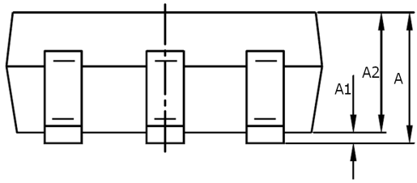  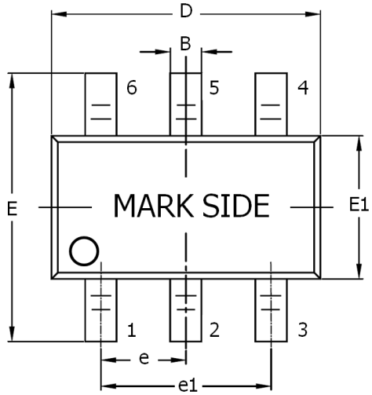 | 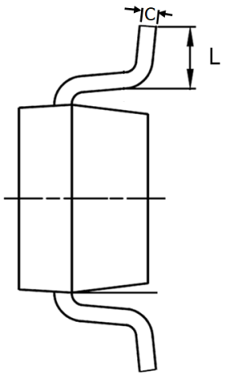
  SYMBOLS UNIT | DIMENSION IN MILLIMETER
  SYMBOLS UNIT | MIN | MAX
  A | 0.70 | 0.95
  A1 | 0.00 | 0.10
  A2 | 0.70 | 0.85
  B | 0.30 | 0.50
  D | 2.80 | 3.00
  E | 2.60 | 3.00
  E1 | 1.50 | 1.70
  e | 0.90 | 1.00
  e1 | 1.80 | 2.00
  C | 0.08 | 0.20
  L | 0.30 | 0.60
Note4: Body dimensions do not include mold flash or protrusion. Mold flash and protrusion shall not exceed 0.3mm.
Carrier Dimensions
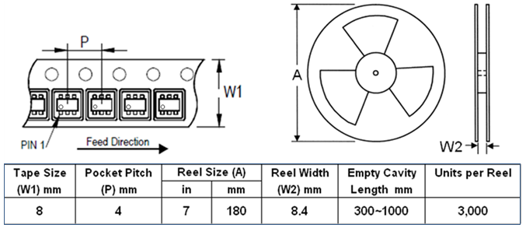

Outline Information (Continued)
SOT-563-6 Package (Unit: mm)
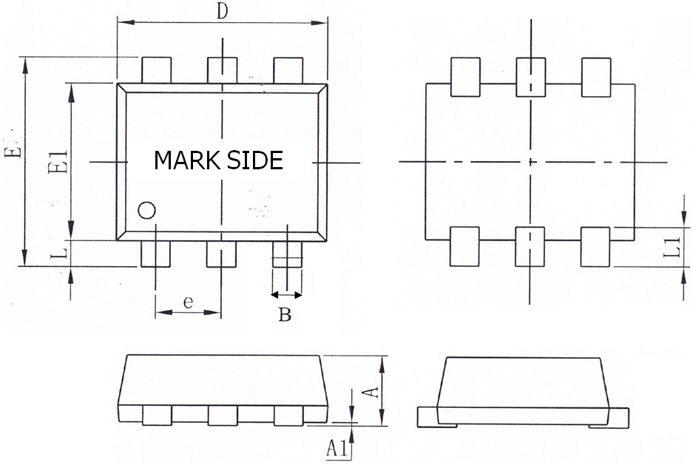
  SYMBOLS UNIT | DIMENSION IN MILLIMETER
  SYMBOLS UNIT | MIN | MAX
  A | 0.525 | 0.600
  A1 | 0.000 | 0.050
  B | 0.170 | 0.270
  D | 1.500 | 1.700
  E | 1.500 | 1.700
  E1 | 1.100 | 1.300
  e | 0.500 BSC
  L | 0.100 | 0.300
  L1 | 0.200 | 0.400
Note 5: Body dimensions do not include mold flash or protrusion. Mold flash and protrusion shall not exceed 0.3mm.
Carrier Dimensions
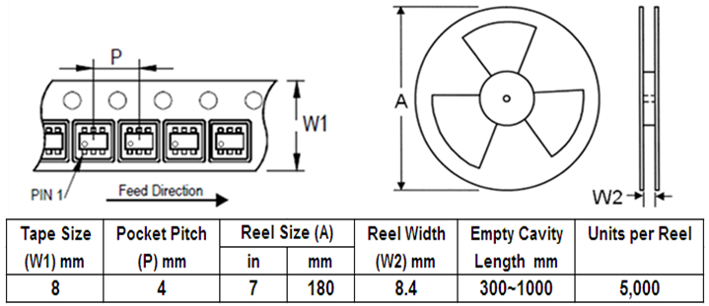

Life Support Policy
Fitipower’s products are not authorized for use as critical components in life support devices or other medical systems.

